MOBILE APPLICATION

FOR

AQUAPONICS SALES

**Submitted by:**

Edoo Jameel Mohammad Ibraheem

Daren Devakumaren Baloomoody

Yogheswar Surjoo

Vibahakarsingh Beeharry

**MODULE NAME: GENIE LOGICIEL**

**Université des Mascareignes**

**Faculty of ICT**

**FEBRUARY 2024**

Table of Contents

**1** **| INTRODUCTION** 3

**1.1** **INTRODUCTION** 3

**1.2** **PROBLEM STATEMENT** 4

**1.3** **AIMS AND OBJECTIVES** 5

**2** **| SYSTEM DEVELOPMENT** 6

**2.1** **UML ANALYSIS AND MODELLING** 6

**2.1.1** **Definition of Actors** 6

**2.1.2** **Definition of Use Cases** 7

**2.1.3** **Use Case Diagram** 8

**2.1.4** **Detailed Description of Use Cases** 9

# **1 | INTRODUCTION**

# **INTRODUCTION**

Mauritius has seen a significant increase in the amount of small aquaponics farmers in recent years. Aquaponics, a sustainable bio-farming method that sees the combination of aquaculture and hydroponics, has piqued the interest of many Mauritians seeking to adopt a better eating lifestyle.

Studies have shown that Mauritius is one of the leading countries in Africa when it comes to the use of pesticides and fertilizers in the agricultural industry.

Aquaponics is often the go to solution for many people in regards to bio-farming, the reason being that it offers a holistic approach to agriculture through the combination of aquaculture and hydroponics to create a self-sustainable system which does not rely on external sources such as chemical fertilizers to stimulate plant growth.

# **1.2 PROBLEM STATEMENT**

First of all, amateur aquaponics practitioner face many challenges when it comes setting up and running an aquaponics system. One of the difficulties many of them face is that they may not be able to provide a constant supply of products to resellers due to their small-scale production. As such, they are obliged to find buyers from the general public on their own to sell their products to.

This can be a troubling task as the only available options are paid advertising which is expensive and non-profitable, and social media advertising which can be a tedious task for many, assuming they have the time to engage in it.

On the other hand, the number of people who are opting for a healthier dietary choice has increased over the years due to concerns of high pesticide usage in in the agricultural industry in Mauritius. And one of the main obstacles for members of the general public in that regards, is the difficulty in locating merchants who sell organic products in their neighborhood.

Not to mention that in most cases, verifying whether these products are in fact organic and well cultivated is not possible for buyers to confirm on their own without the help of a third party organization.

# **1.3 AIMS AND OBJECTIVES**

The primary objective of this project is to create a mobile application with the purpose of establishing a connection between amateur or small-scale aquaponics practitioners across Mauritius and members of the general public who are looking for sellers of organic products in their vicinity.

The mobile application will be affiliated with an organization dedicated in the promotion and education of either aquaponics or organic farming in general in Mauritius. The main reason for this, is because this organization will have the responsibility of allowing only merchants who are selling organic aquaponics products to gain access to the application’s merchant side.

In regards to the problems faced by small aquaponics merchants in Mauritius, by way of establishing a connection between the merchants and buyers interested in their products, be it small-scale producers or amateurs, aquaponics practitioners will no longer have to worry about finding clients on their own.

When it comes to members of the public, finding merchants who are selling certified organic products, specifically aquaponics products, will prove to be much easier.

The mobile application will allow merchants to display their products along with their location. Members of the public will then be able to locate the closest merchants to them or find merchants by searching for products or specific locations directly.

# **2 | SYSTEM DEVELOPMENT**

# **2.1 UML ANALYSIS AND MODELLING**

The system development phase will begin with an analysis of the requirements of the system to accomplish defined tasks within the system.

This will be accomplished using the principles of Unified Modelling Language (UML); more specifically, we will define the actors and use cases within the system along with UML diagrams to provide a visual representation.

# **2.1.1 Definition of Actors**

“Actors can be defined as something that interacts with the system. The actors can be human user, some internal applications or may be some external applications.” (Waykar, 2015)

Actors within the system can be divided into two categories, namely, primary actors and secondary actors.

**Primary Actors**

An actor who requires the development of one or more functionalities within the system to be able to accomplish their defined tasks is referred to as a primary actor.

The mobile application constitutes only of the following primary actors:

* Aquaponics Merchants
* Clients
* System Administrators

# **2.1.2 Definition of Use Cases**

The definition of a use case in light of this project is a written description of a specific task or action which will be performed by the primary actors of the system within the mobile application.

* The list of use cases to be performed by the pre-registered aquaponics merchants:

1. Type of User Selection (Seller or Buyer) – Select Seller

2. User Authentication Only (Sign In)

3. Input their contact info, address and location within the app

4. Input their products & related information

5. Receive & approve orders placed by clients along with notifications

6. Receive/Send direct messages from clients via the app

* The list of use cases of clients from the general public:

1. Mode Selection (Seller or Buyer) – Select Buyer

2. User Registration (Sign Up)

3. User Authentication (Sign In)

4. Input their contact info, address and location within the app

5. Viewing available aquaponics merchants close to them

6. Searching for merchants based on specific products & a specified location or town

7. Place Orders from merchants – specify amount, delivery/pickup, payment mode (Cash/Juice)

8. Send/Receive direct messages to merchants

* The list of use cases for System Administrators:

1. User Authentication (Admin Login)

2. Merchant/Seller registration

# **2.1.3 Use Case Diagram**

The purpose of a use case diagram is to produce a visual representation of the operational mechanism of the web application and its use cases in relation to the actors of the system.

This diagram facilitates the development process since the developer can clearly see the interactions between the different parts of the system.

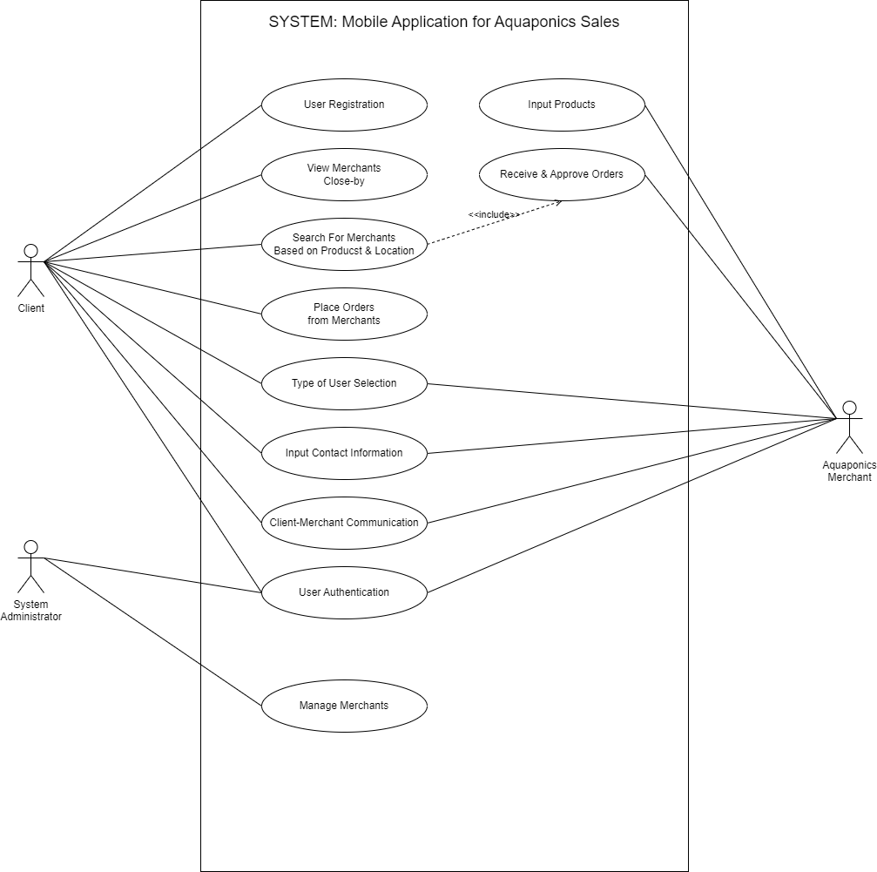

**Figure 1: Use Case Diagram**

# **2.1.4 Detailed Description of Use Cases**